LINUX BASIC ASSIGMENT

STEP1. Create directory

Explanation: test_dir naam ki directory bani mkdir test_dir se

STEP2: Enter directory


Explanation: test_dir k aandar cahala jata hai

Step3 : Create empty file


Explanation : example.txt naam ki empty file banata hai.

Step4 : Rename file
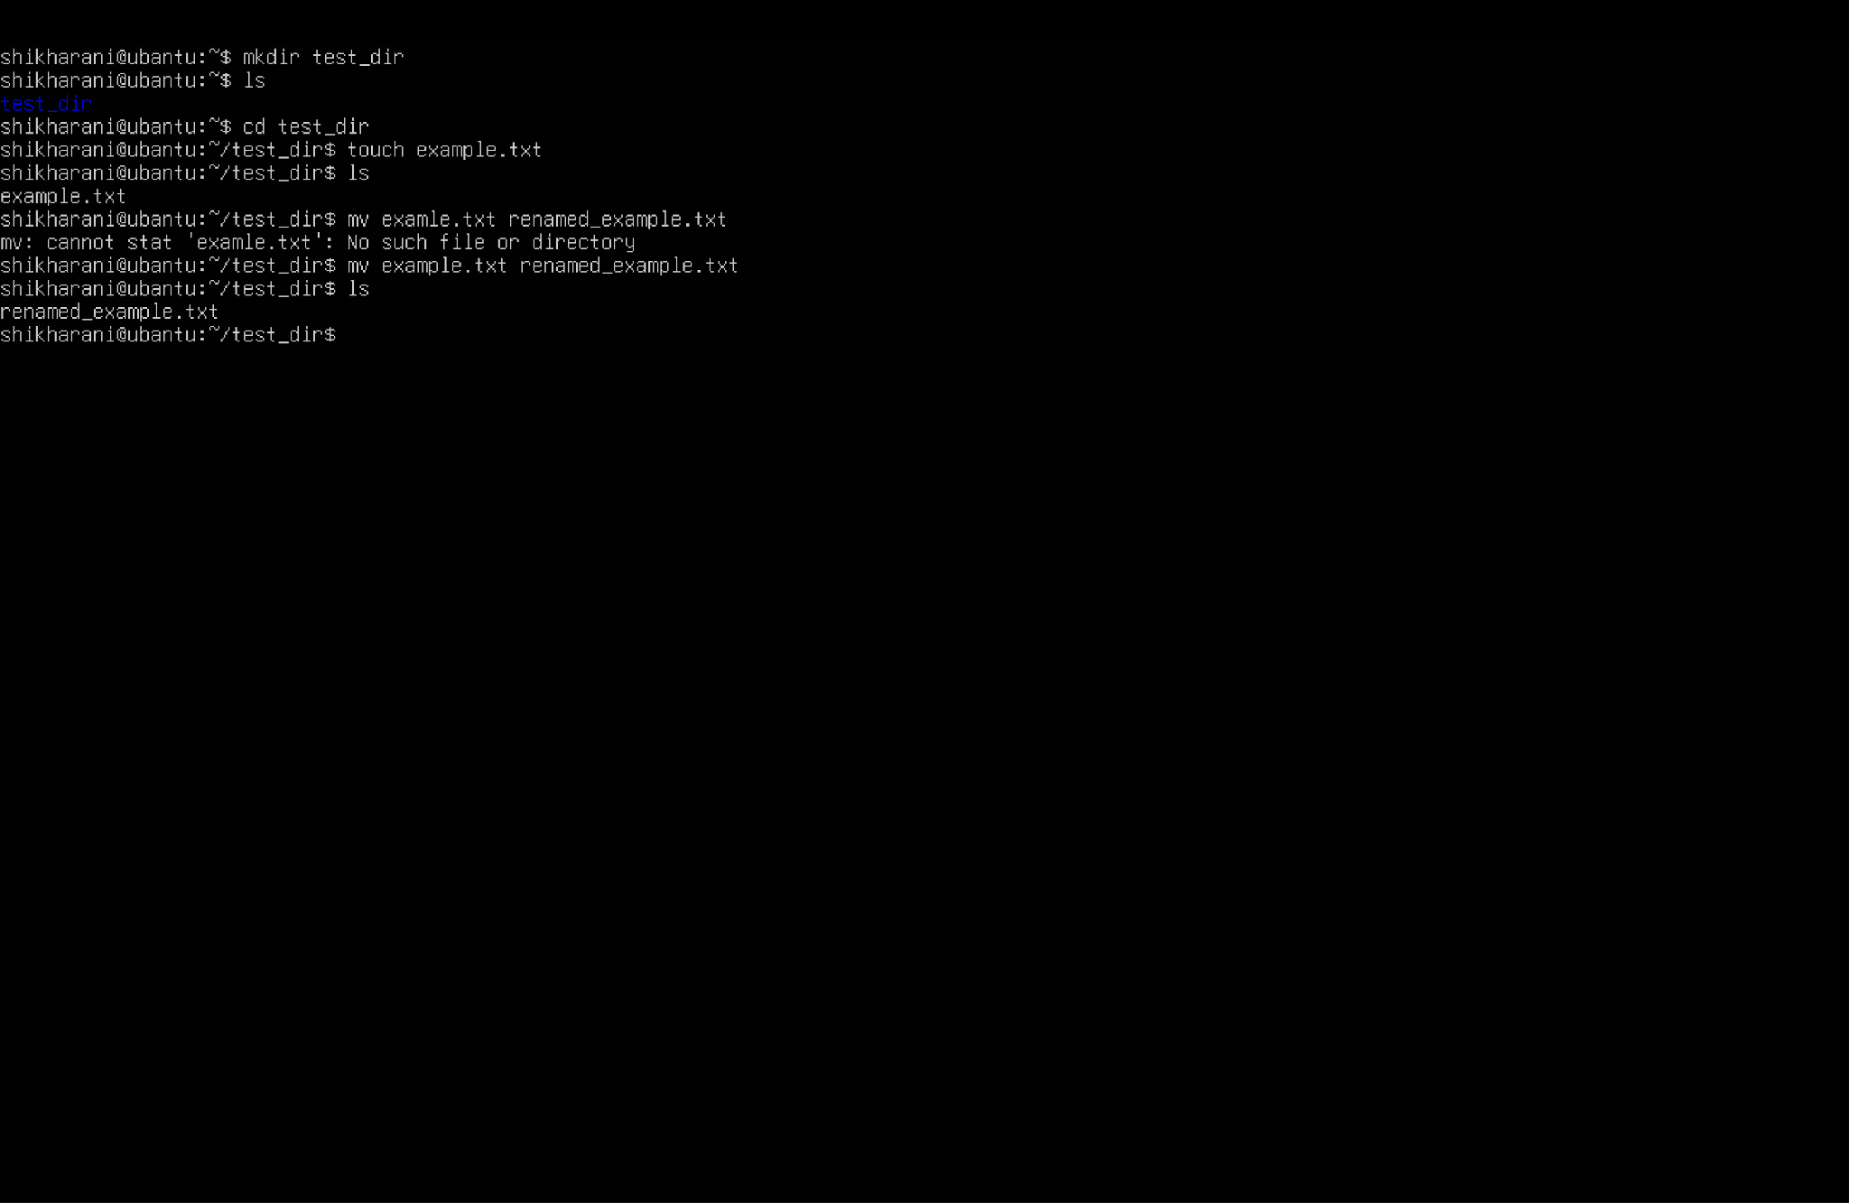

Explanation : file ka naam badal deta hai

Step5: Viewing file contents

- /etc/passwd li poori file dekhna : poora content dikhata hai.
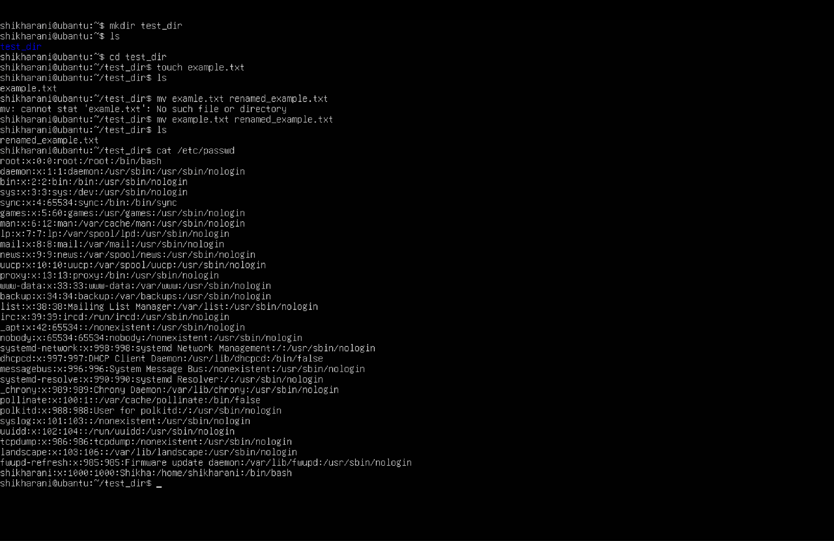

- Sirf 5 line dikhata hai head -n 5 /etc/passwd
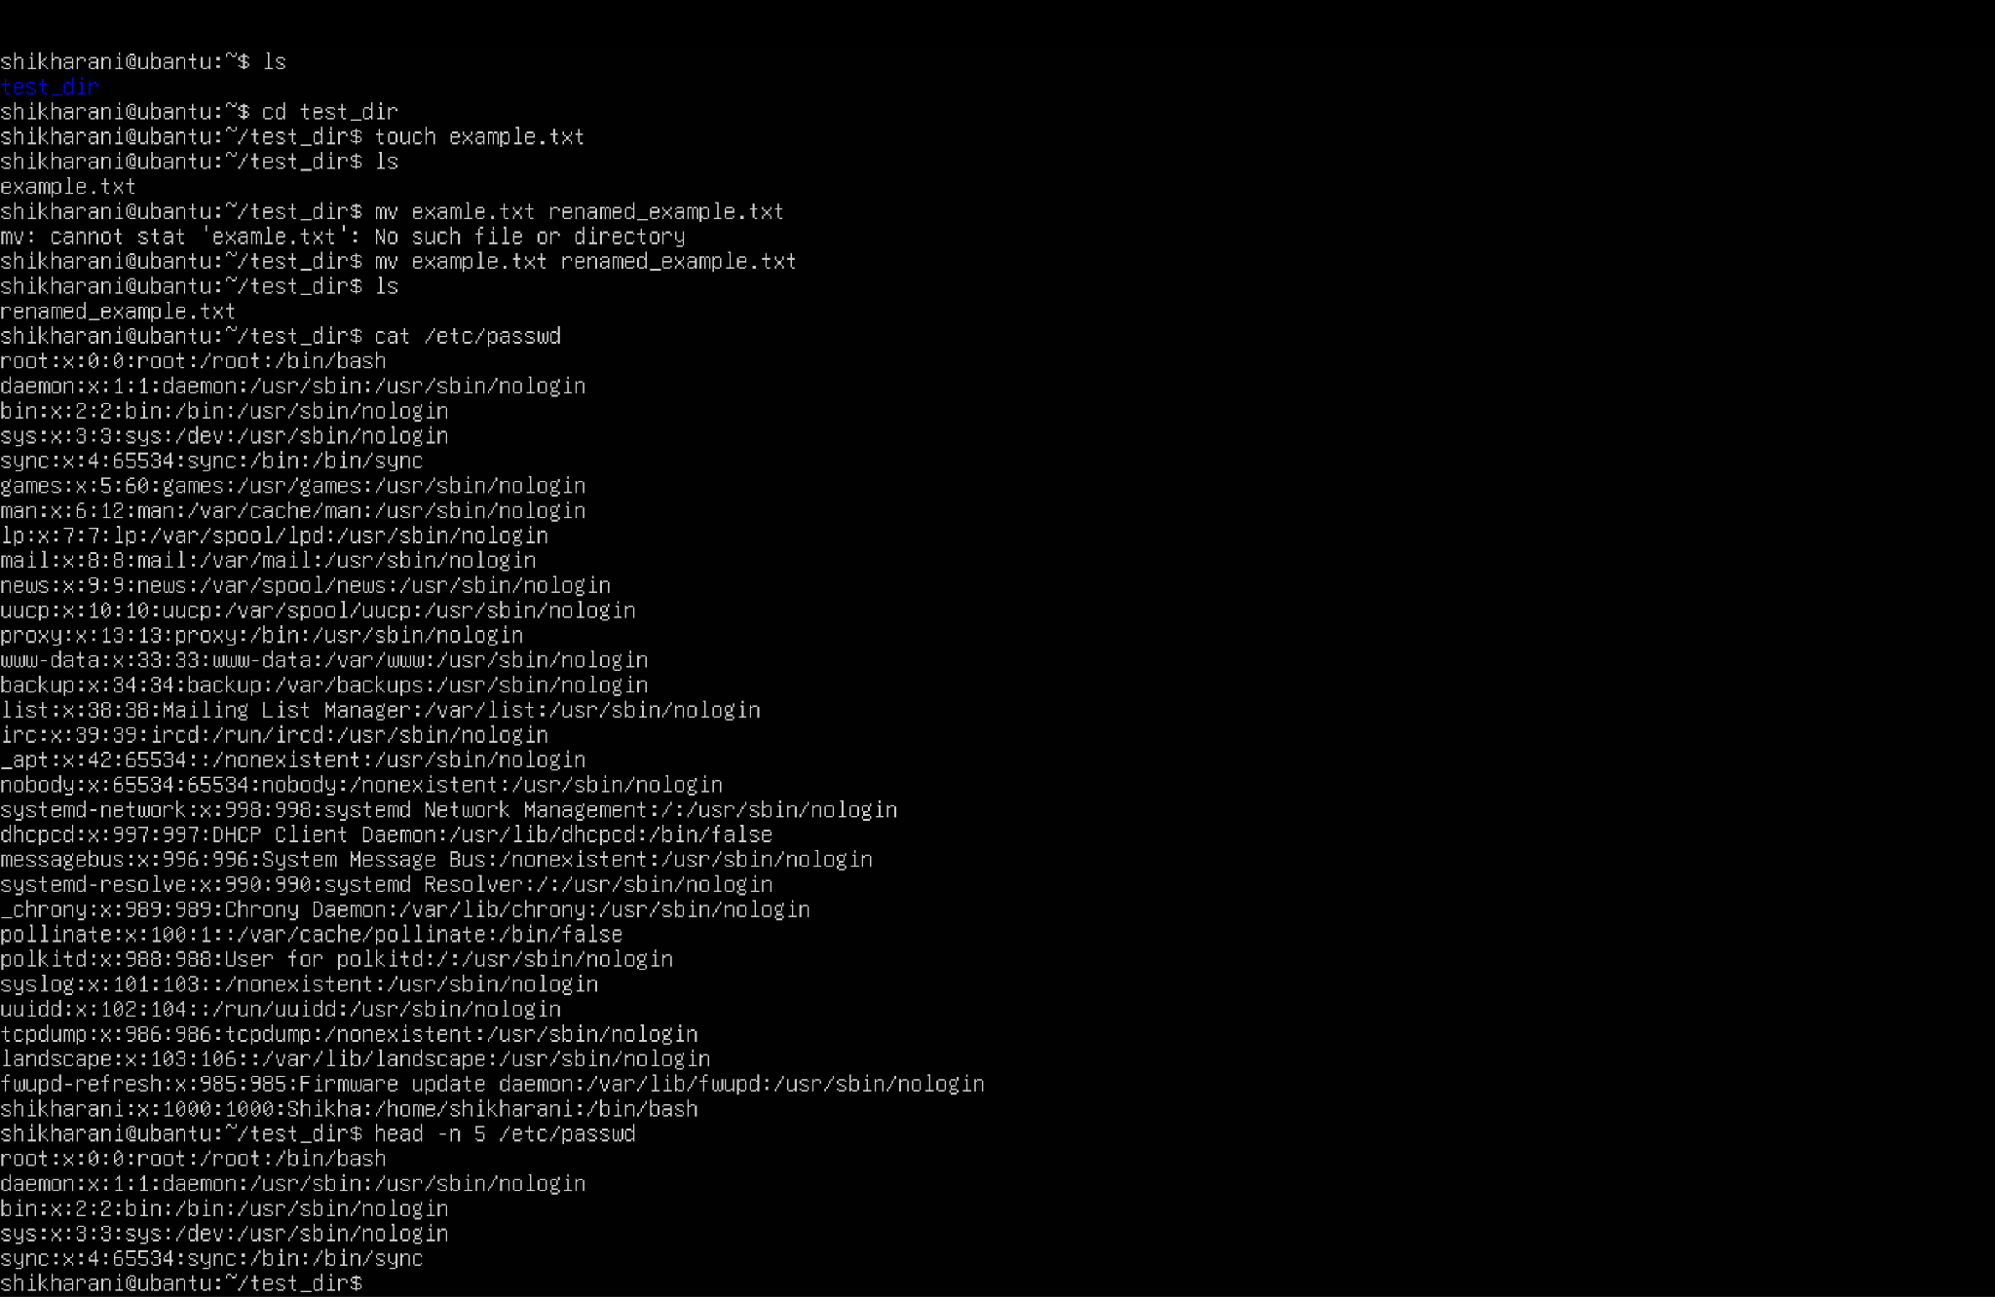

{c} : sirf last 5 lines dilkata hai (tail -n 5 /etc/passwd)
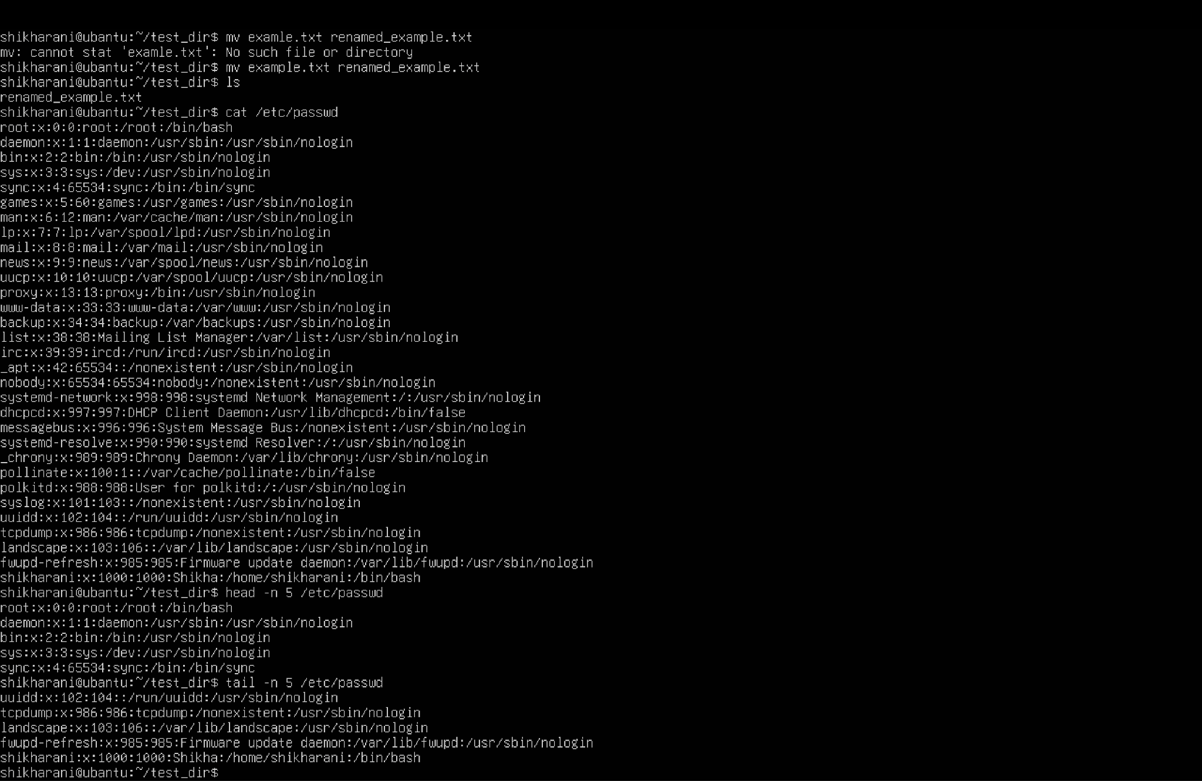

Step 6 : Searching for patterns
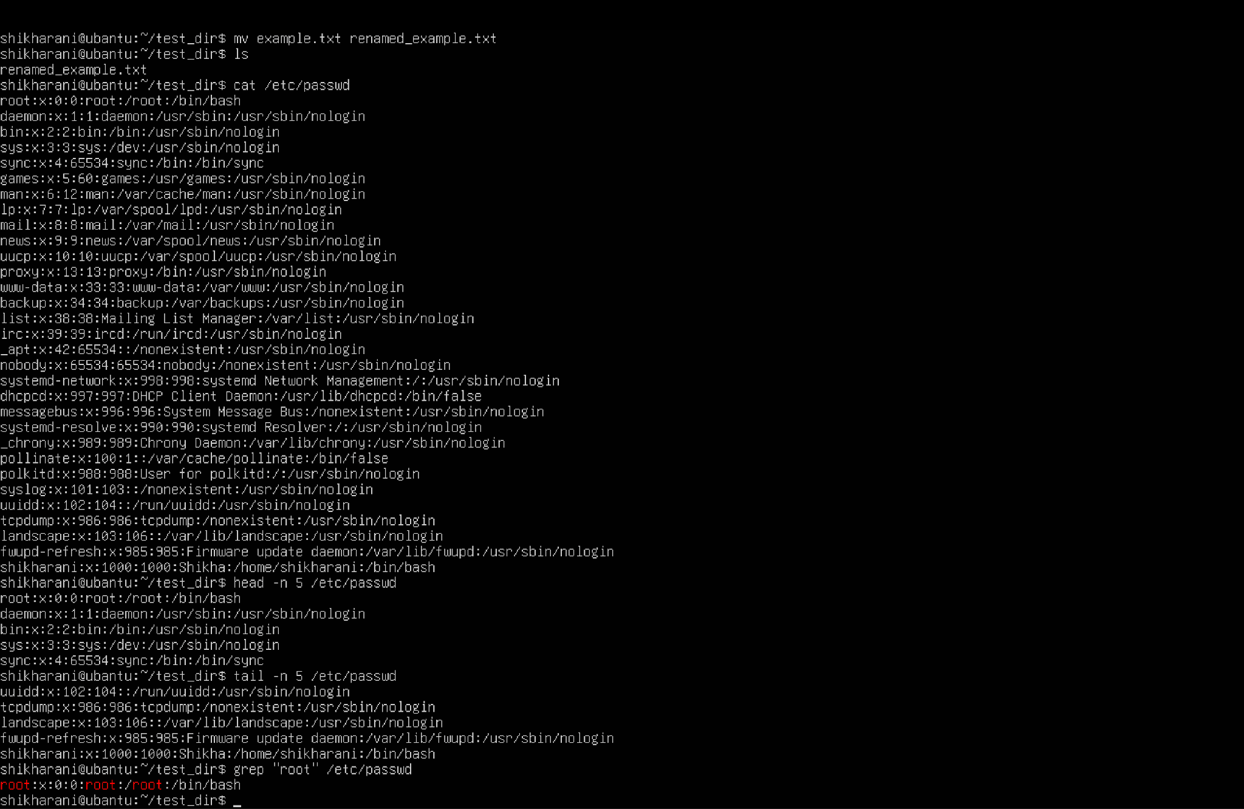

Explanation: /etc/passwd me root word wali lines dikhata hai.

Step 7 : Zipping and Unzipping
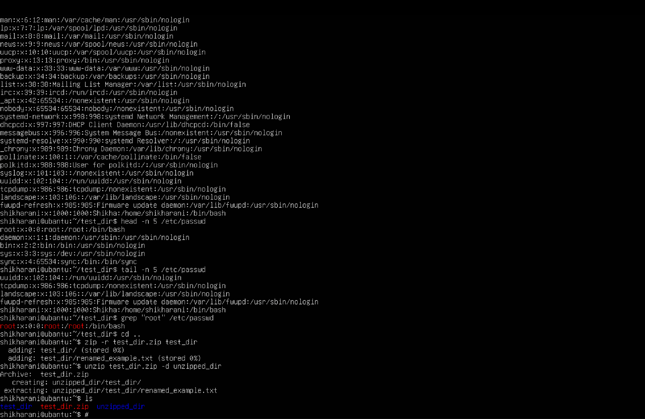
Step 8: Downloading a file
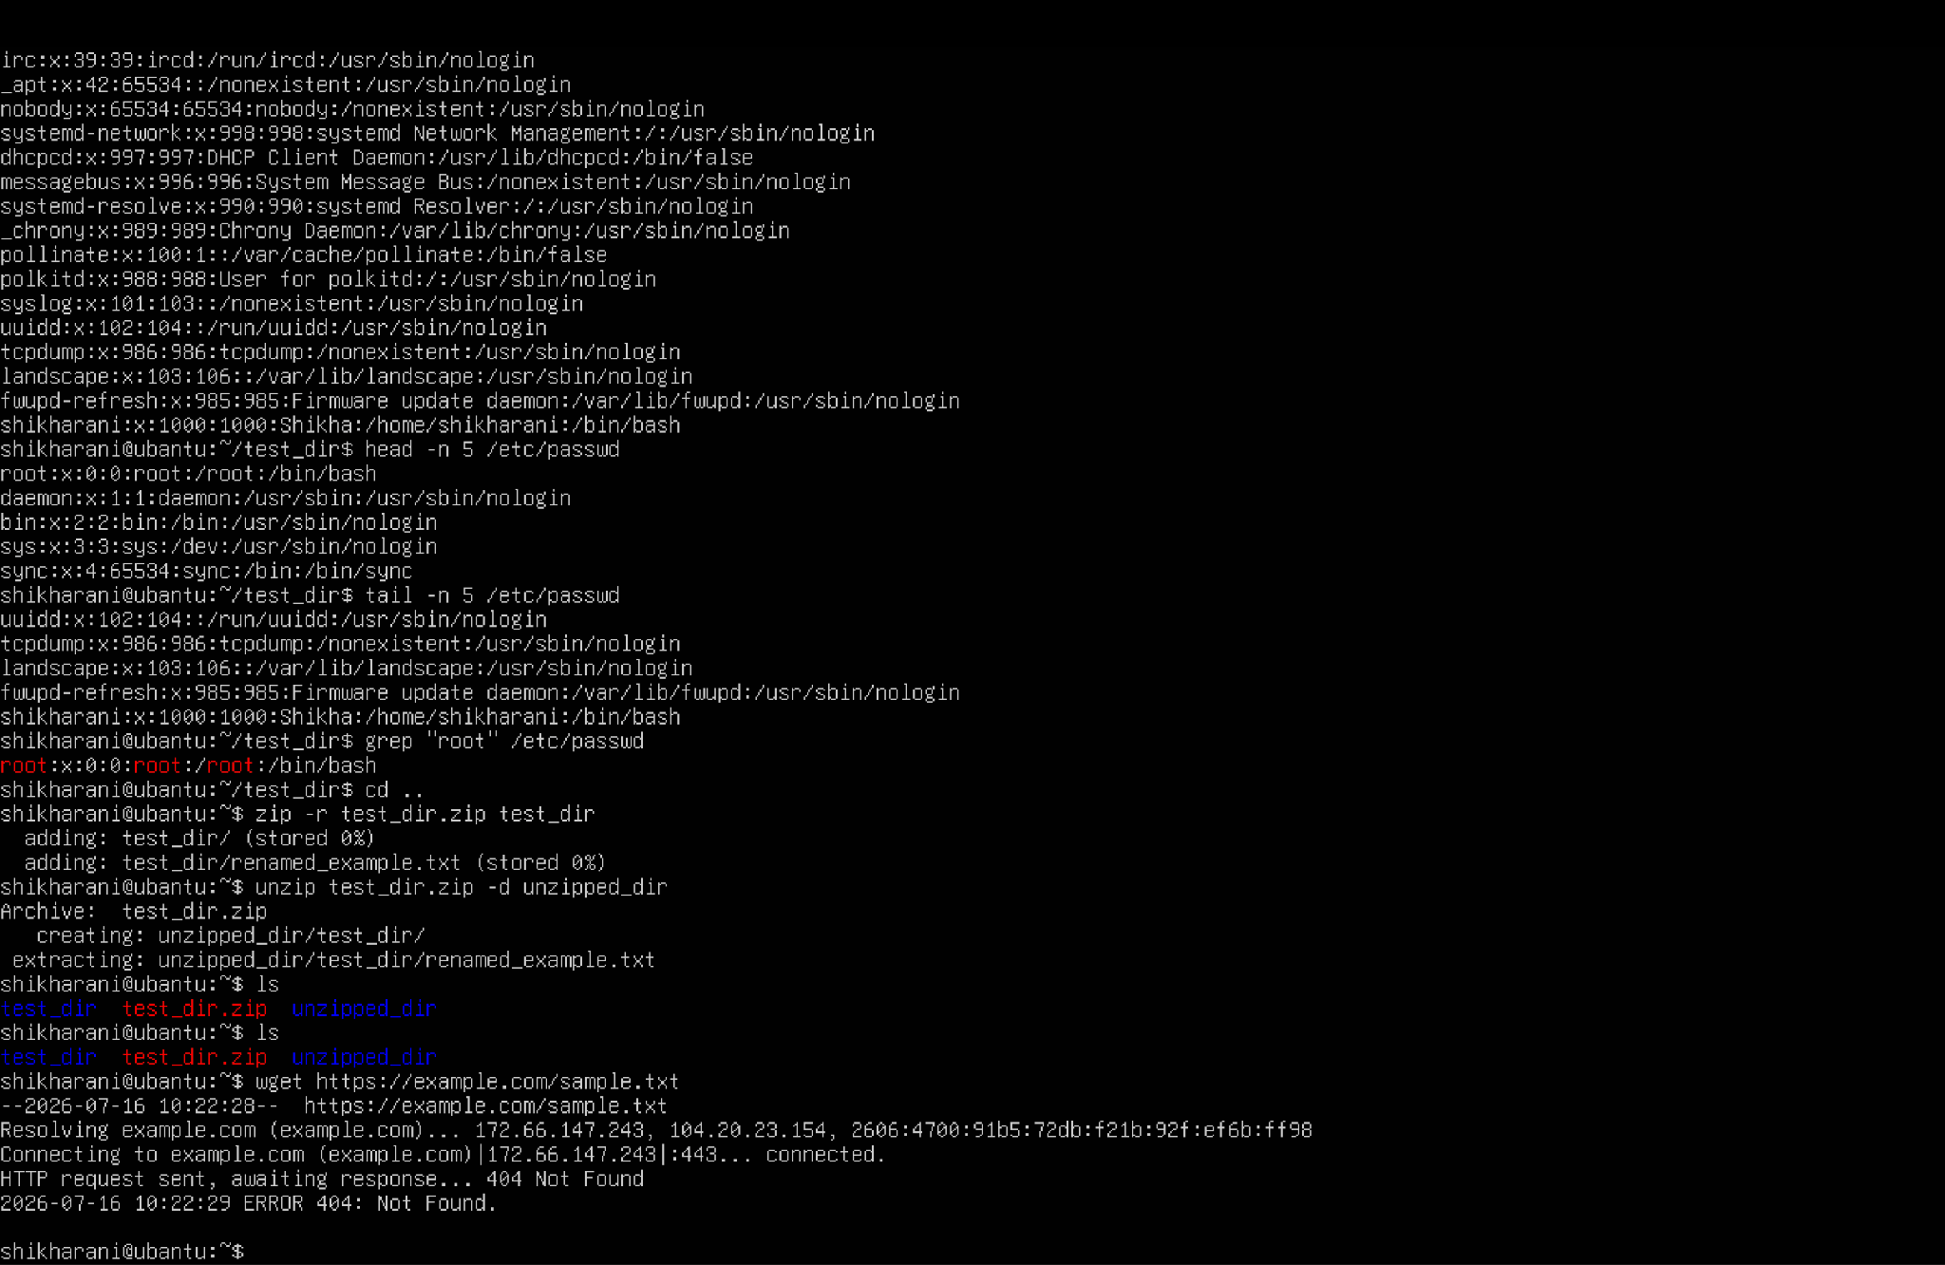

Step 9: Changing permission
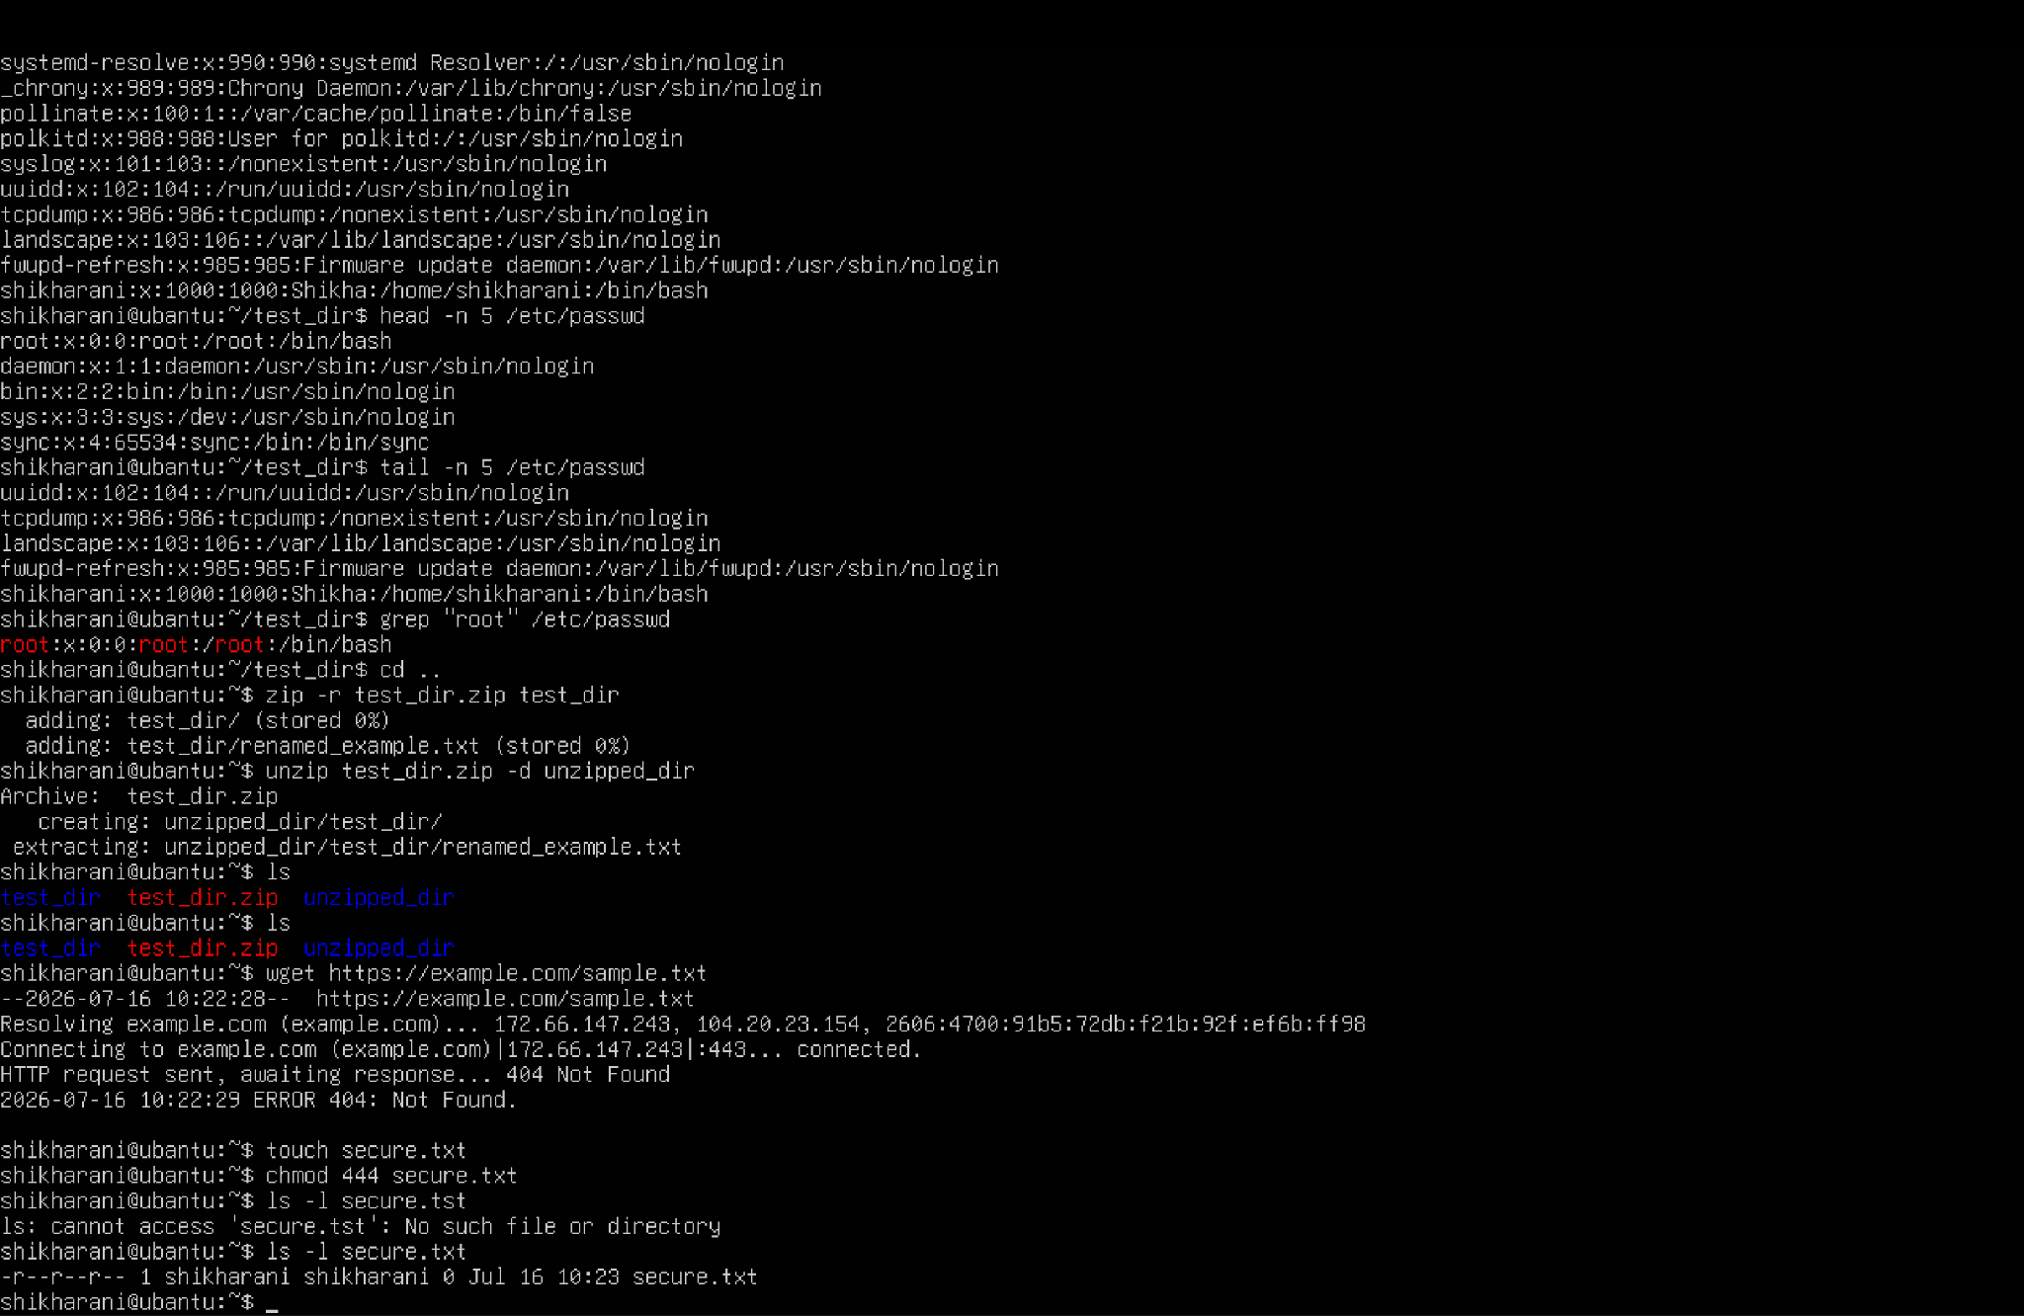
Step 10: Environment variable
